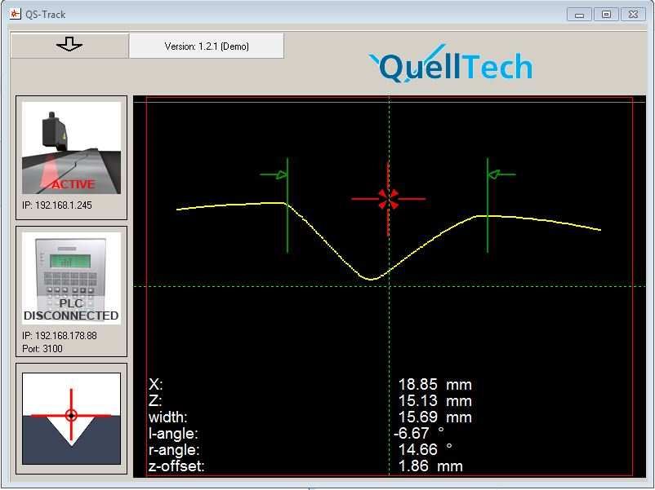

QS-Track Software
For usage with K4 Laser-Scanner
Operators Manual

V. 1.2.5-E

© 2018 QuellTech GmbH Germany, All rights reserved. The authors do not assume any liability whatsoever for the accuracy and/or completeness of the information in this document,
neither for the consequences that may occur due to the use of this documentation. It is not allowed to copy any part of this documentation, to any sort of form, whether electronically nor
mechanically, nor is it allowed to reproduce any part for any purpose, except for the purpose of project evaluation, provided the permission of an explicit written authorization. This
documentation is copyrighted and is not allowed to be passed on to unauthorized third parties.

Table of Contents
1. Software QS Track ........ ............................................................................................................. 3
1.1. Installation ............... ............................................................................................................... 3
1.2. Enter settings mode ............................................................................................................... 3
1.3. Select the desired program function: ................................................................................... 4
1.4. Input optional Settings ........................................................................................................... 5
1.5. Main View ................................................................................................................................ 6
1.6. Unlock Demo Version ............................................................................................................ 7
2. QS-Track TCP/IP –PLC Interface Structure .............................................................................. 8
2.1. Changing the Measurement Program ................................................................................... 8
2.2. Data Request Commands from PLC to Software: ................................................................ 8
2.3. Return String Format: ............................................................................................................ 8
2.4. Examples .............................................................................................................................. 10
3. Scanner Connections .............................................................................................................. 12
3.1. Ethernet connection ............................................................................................................. 12
3.2. Control cable ........................................................................................................................ 12
3.3. Instructions ........................................................................................................................... 12
3.4. Product labeling ................................................................................................................... 12
3.5. General system description ................................................................................................. 12
3.6. Encoder data for position .................................................................................................... 13
3.7. Technical Specifications ...................................................................................................... 13
3.8. Description of Web-Interface ............................................................................................... 13
3.9. Changing the IP-address ..................................................................................................... 14

1.Software QS Track

1.1.Installation
There is no installation necessary, copy the program file into a folder and double-click it
1.2. Enter settings mode
Connect a K4 scanner and verify its IP No and port No as described above.
To enter the settings click on the arrow button and enter “qst1” into the field, hit return

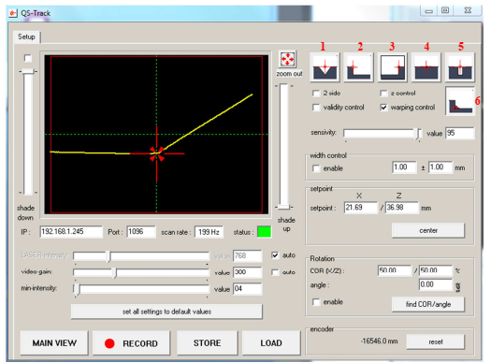

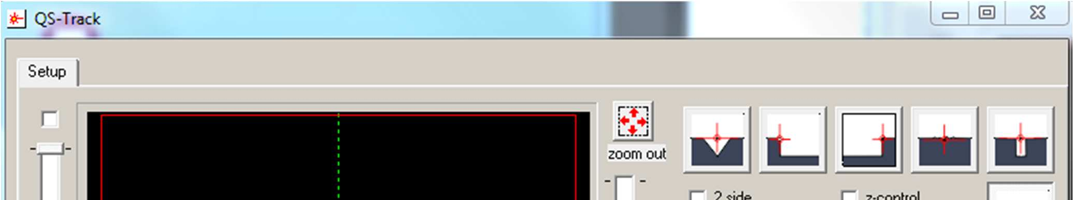

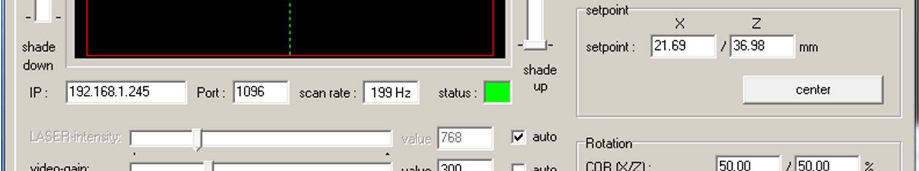

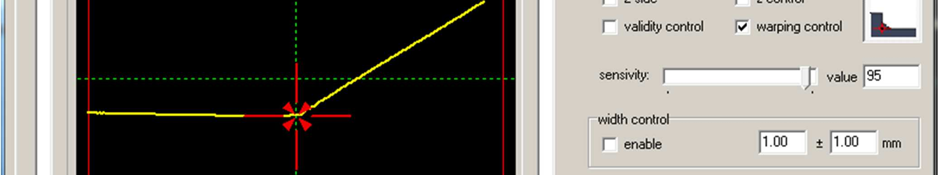

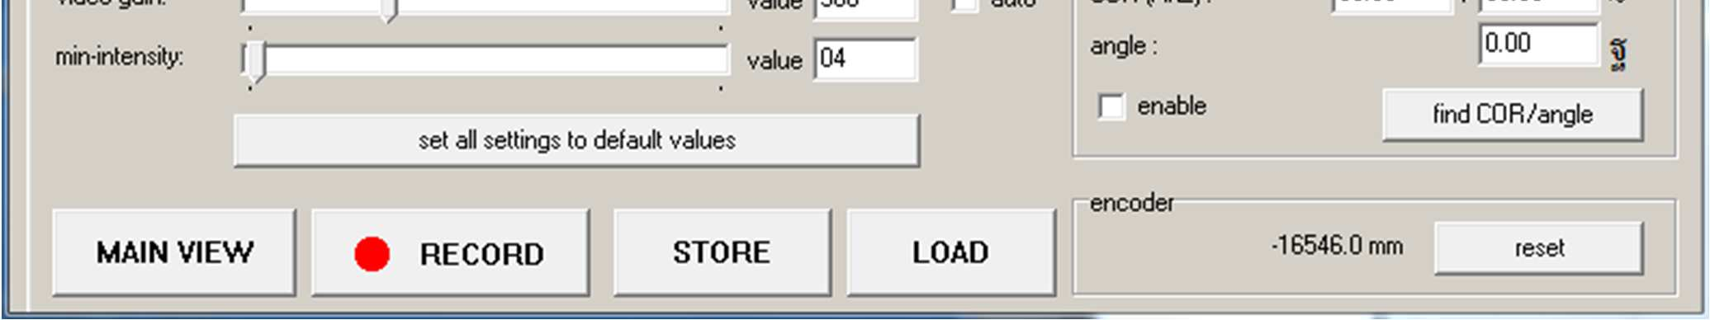

The red numbers refer to the functions/settings described here

1.3. Select the desired program function:
1. Center of gap
2. Left edge
3. Right edge
4. Flat gap
5. Small gap
6. Fillet tracking

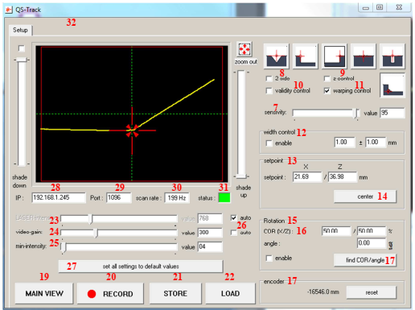

The red numbers refer to the functions/settings described here

1.4. Input optional Settings
For all these values: try to use the default settings first, if these do not work sufficiently, then try to optimize
altering these settings
7. Sensitivity: set sensitivity of detection
8. 2 side: check for detecting rising and falling edges, uncheck for only falling edges
9. Z control: if no gap, old x position will be continued
10. Validity control: Eliminates singular effects like sputter
11. Warping control: excludes edges left/right of gap
12. Width control: suppresses detection of gaps with wrong nominal width
13. Setpoint: set the coordinates of the reference point
14. Center: sets the current measured point as reference point
15. Rotation: compensates possible scanner inclination
16. COR: set position of center of rotation (COR)
17. Find COR/angle: tries to find the optimal COR
18. Encoder: reset encoder value
19. Main View: after settings input change to the Main View window
20. Record: records all profiles until untoggled
21. Store: all settings in settings.ini
22. Load: loads all previously stored settings from settings.ini
23. Laser-intensity: regulates how much laser light will be output, best to keep on auto
24. Video-gain: set video gain, standard setting should be 300
25. Min-intensity: sets threshold for min. intensity of pixel
26. Check these boxes to use default values of the scanner (recommended for Laser-intensity, not
recommended for video-gain)
27. Set all setting back to default values

- IP: use IP which the scanner is running on (default or working IP)
29. Port: use port which the scanner is using (see web interface of scanner)
30. Scan rate: shows current rate of profiles/s
31. Status: green if scanner is running and connected to software, red if no connection.
32. Unlock Demo Version: insert unlock code if communication to external systems needs to be activated.
This is tab is only present before activation (see chapter 2.6).

1.5. Main View

1. Shows reference point (center point of gap)
2. X coordinates of center point
3. Z coordinates of center point
4. Width of gap
5. Angle of adjacent surface to the left relative to the horizon
6. Angle of adjacent surface to the right relative to the horizon
7. Shows offset relative to center point previously set in the settings
8. Shows if scanner is active
9. Shows if PLC is connected
10. Shows currently selected program function

1.6. Unlock Demo Version

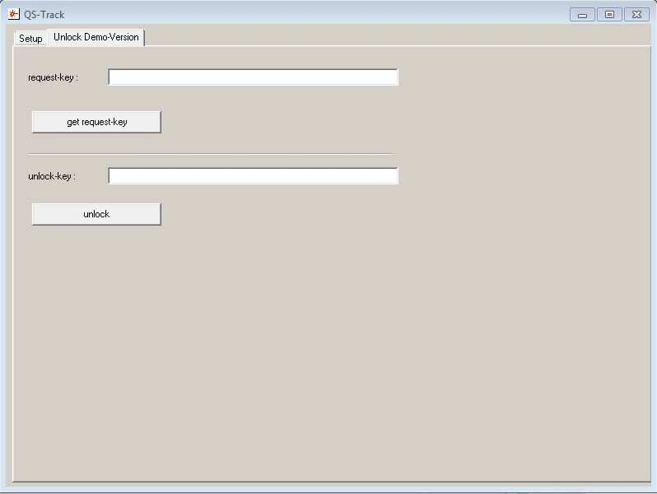

To be able to communicate via the TCP Interface Port 3100 with external systems, it is necessary to obtain a
unlock key from the manufacturer. To do this, enter the settings mode as described in chapter 2.2 and press the
above highlighted button.
On the target system generate a request key by clicking on “get request-key” button. Mail this request key to
info23@quelltech.de
If you are authorized for an unlock key you will then receive an unlock-key which you must insert into the field
and click “unlock

- QS-Track TCP/IP –PLC Interface Structure
The IP as well as the port of the PLC interface can be found in the main window. Default-TCP-Port is 3100.
By establishing a connection it is possible to set the measurement program and to request data.
  - Changing the Measurement Program
In order to set the algorithm of QS-Track to another one, the following String should be sent:

String: |S|M|**|CR| (“|” are placeholders and CR = Carriage Return = 0x0D)
Hex: |53|4D|**|0D|

Depending on which program should be used, substitute the ** with the values from the following table:
00 – 0x30 – none
02 – 0x32 – fillet tracking
03 – 0x33 – center of gap
06 – 0x36 – flat gap
07 – 0x37 – small gap
08 – 0x38 – left edge
09 – 0x39 – right edge
  - Data Request Commands from PLC to Software:
In order to receive the current measurements of QS-Tracking, there are two commands that the PLC can send:
“Get Custom Values”
String: |G|V|C|CR| (“|Get|Values|Custom|Carriage return|”)
Hex: |47|56|43|0D|
→ Returns the values that are shown in the Window (e.g. X, Z, slope, for mode “right edge”)
“Get All Values”
String: |G|V|A|CR| (“|Get|Values|Custom|Carriage return|”)
Hex: |47|56|41|0D|
→ Returns all values that are specified in settings.ini in under the mark “[Results over Ethernet]”

  - Return String Format:
The format of the string is as follows:
Hex: |Header |Length|Result Value +|Status|
(“+” means that depending on the algorithm and request command there will be a different amount of result
values being sent).
Result Value
The returned result value will be of the form |Index|(In-)Active|”->”|Measurement|
With Index as being specified in below list and:
A for Active for all indices which are being used for calculation of that algorithm
I for Inactive for all indices which are not being used but specified in the settings.ini

[Results over Ethernet]
V00: Center=1
V01: Distance=1
V02: L-Distance=0
V03: R-Distance=0
V04: Z-Offset=0
V05: Width=1
V06: Slope=0
V07: L-Angle=0
V08: R-Angle=0
V10: Seam_Height=0
V20: Encoder=0
V62: Temperature=0
V31: Setpoint_X=0
V44: Setpoint_Z=0
V30: Hysteresis=0
V32: Min_Height=0
V46: Width_Setpoint=0
V47: Width_Tolerance=0
V33: Angle_Setpoint=0
V15: Profile_Intensity=0
Additional Commands that could be included in the settings file are:
V11 - L-Groove Depth [mm]
V12 - R-Groove Depth [mm]
V13 - Area [mm]
V34 - Groove Calibration Offset [mm]
V35 - Left Gap Level [mm]
V36 - Right Gap Level [mm]
V37 - Filter Depth
V38 - Search Depth
V39 - Search Appx
V40 - Max Slope [°]
V41 - Min Side Length [Pts]

Status
The Status has the format
Hex: |C|XXXXX|M|**|CR|
Where XXXXX is the decimal representation of the 16 bits long status as seen in the following table and ** is
again the algorithm mode in String representation as seen in chapter 3.1.
Bit 0 ( 1) -> Scanner OK
Bit 1 ( 2) -> Scanner connected
Bit 2 ( 4) -> Profile
Bit 3 ( 8) -> Recognition OK
Bit 4 ( 16) -> Intensity > 25%
Bit 5 ( 32) -> Intensity > 50%
Bit 6 ( 64) -> Intensity > 75%
Bit 7 ( 128) -> Heartbeat
Bit 8 ( 256) -> Position too right
Bit 9 ( 512) -> Position OK
Bit 10 (1024) -> Position too left
Bit 11 (2048) -> FIFO load, performance problems
Bit 12 (4096) -> Recording
Bit 13 (8192) -> reserved
Bit 14(16384) -> Position Centered
Bit 15(32768) -> reserved

  - Examples
---------------------------------------------------------------------------------------------
|0xFF|0xFE|xx|yy|V|0|0|A|>|+|0|0|1|.|2|3|CR|V|0|1|A|>|-|0|0|1|.|2|3|CR|V|0|5|A|>|-|0|0|1|.|1|2|CR V|0|6|I|>|-
|0|0|5|.|0|0|C|0|0|0|0|0|M|0|0|CR|
// 76 bytes max. length. Once defined, the length should be kept constant in PLC
---------------------------------------------------------------------------------------------
The length starts after 0xFF and 0xFE bytes.
xx Length of Return-String lo-Byte // set by system
yy Length of Return-String hi-Byte // set by system
Example with Hercules
In this image example, first, the algorithm for the measurement will be changed and later the All Values of the
current measurement requested.
- Program Mode after startup is “Right Edge”

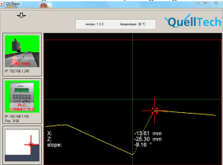

- Hercules is successfully connected

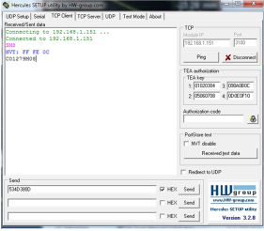
By sending the highlighted String, the mode can
be changed as seen in 3. The returned value is
the current status.

The program mode was successfully changed
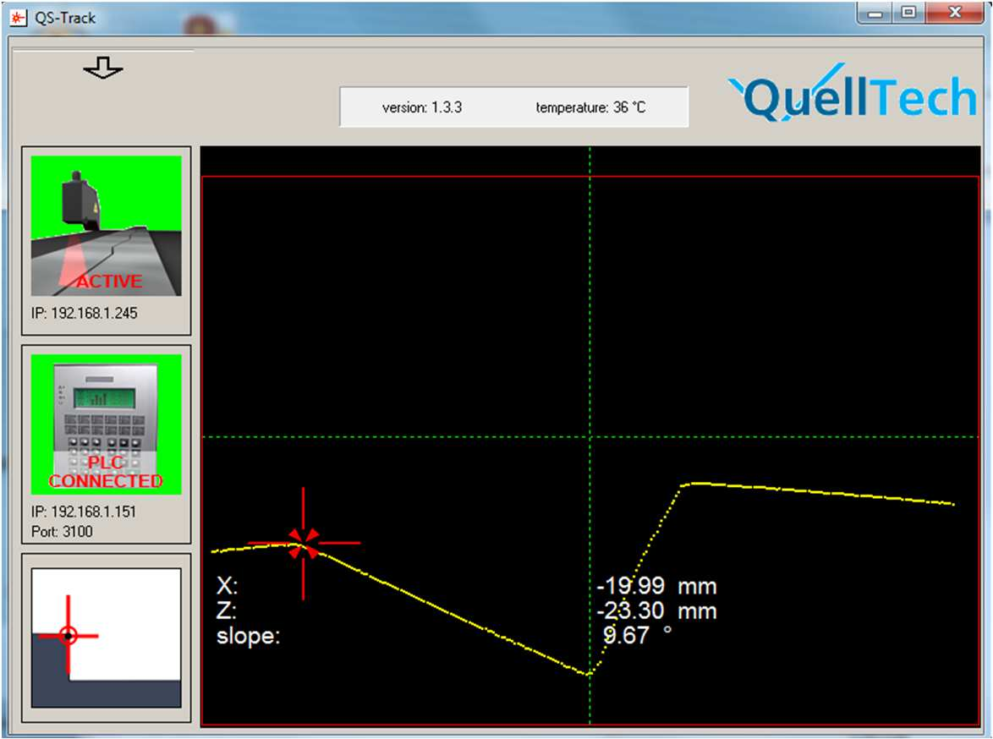

Requesting the current data with the request String

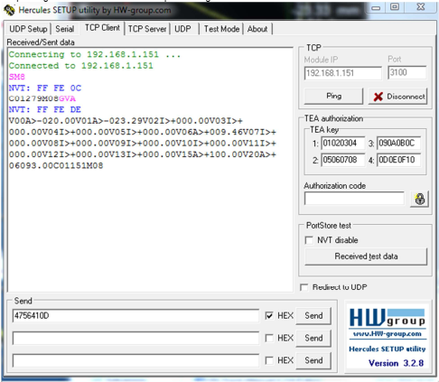
As expected, the String is sent from QS-Track. V00 is A(ctive) with the value of -20.00mm (recall: Center of
desired point of interest -> left edge).

- Scanner Connections

  - Ethernet connection
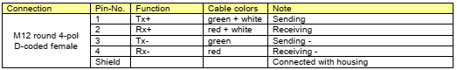
  - Control cable
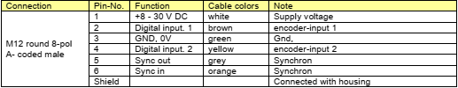

  - Instructions

- Connect the Ethernet cable directly or via switch to a PC.
2. Connect the supply voltage 24V DC according to above scheme. (It is highly recommended to use a
high quality power supply with high EMC robustness)
3. The default IP address of the scanner is 192.168.1.245. Port 1096, adjust the PC network settings
accordingly.
4. Apply power and you should see a red laser line.
5. Ping the scanner. If you see a response, ok, if not check the cable connections again, check the IP
settings at the PC and the scanner. If necessary reset the scanner pressing the reset button for 5 sec.

  - Product labeling
Following scanner details on the cover label:
Manufacturer: KPM
Type: K4-xx
Serial no.: xxxxxx

  - General system description
Plug the scanner with a M12-D-coded standard industrial Ethernet connecting plug,
as well as an 8-pin M12-A-coded control- and power supply plug.
On the plug surface 2 system indicators are integrated with the following features of function:

Status LED’s | Meaning | color | OK when
System ok | Iluminates after self check | red | flashing
LAN act. | Ethernet Link sending data | yellow | flashing

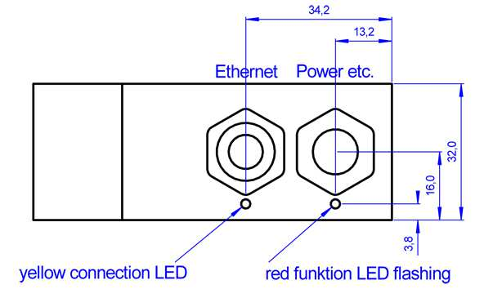

The button „reset IP“ is to be used in order to provide the scanner with the default IP-address: 192.168.1.245
The scanner includes a CCD-sensor, a line laser and the electronics for the consolidation of the cloud of points..
The scanner provides a 2D scan of an object on the measurement range.
The width of the scan will be indicated with an X-value, the depth of the measurement will be indicated
with a Z-value. The linearization of the scanner has been carried out in the factory. Profile data are send in
metric values. A calibration by the user is not necessary. Therefore every scanner can be exchanged on-site,
without any extensive new calibration necessary.
The evaluation electronics in the head of the scanner will carry out all settings automatically, in order to provide
always the optimal profile.
  - Encoder data for position
The encoder data for position are only available when an incremental encoder is connected to the inputs 1+2.
The position value is registered at the end of a scan, in order to receive for every profile the corresponding
encoder data for position.
Values are in binary complement.
Encoder inputs:
Protocol Incremental Signal A+B 90° Phase shifted
Input level Low = 0 ... 2 V High = 5 ... 30 V

3.7. Technical Specifications
Ethernet Interface:
Default IP-address 192.168.1.245
Default Port 1096
Default Subnet mask 255.255.255.0
Transmission rate 100 Mbit
Protocol TCP/IP-Protocol
Auto negotiation yes
Auto MDIX yes
DHCP no

Other:
Temperature probe Value range -55°C to +126°C in 1 grade steps
Operating hours counter counting interval = 250 ms
Switch-on counter Every time the sensor is turned on, the value will increase to 1.

3.8. Description of Web-Interface
Address the scanner by using the integrated Web-Interface with the help of a web-browser. Input the Scanners
IP address into the web-browsers address field.
The parameters as well as the scan profile will be indicated.

A scan profile update will not be performed automatically. A scan profile update will only be indicated new after
having updated the website.
Additionally, the access with the web-browser allows the possibility to set up directly the working IP-address, the
Port and the Subnet mask.
3.9. Changing the IP-address
In order to be able to change the IP-address, include the new data into the entry mask.
The password is: q4
After having sent the data with „Change IP-address“, the scanner will provide a report with a new screen page
on which the new data are being confirmed. Do not forget to set your PCs address accordingly.
